Subclassing, such as in

unsplash.com/s/photos/kangaroo  
by john-torcasio

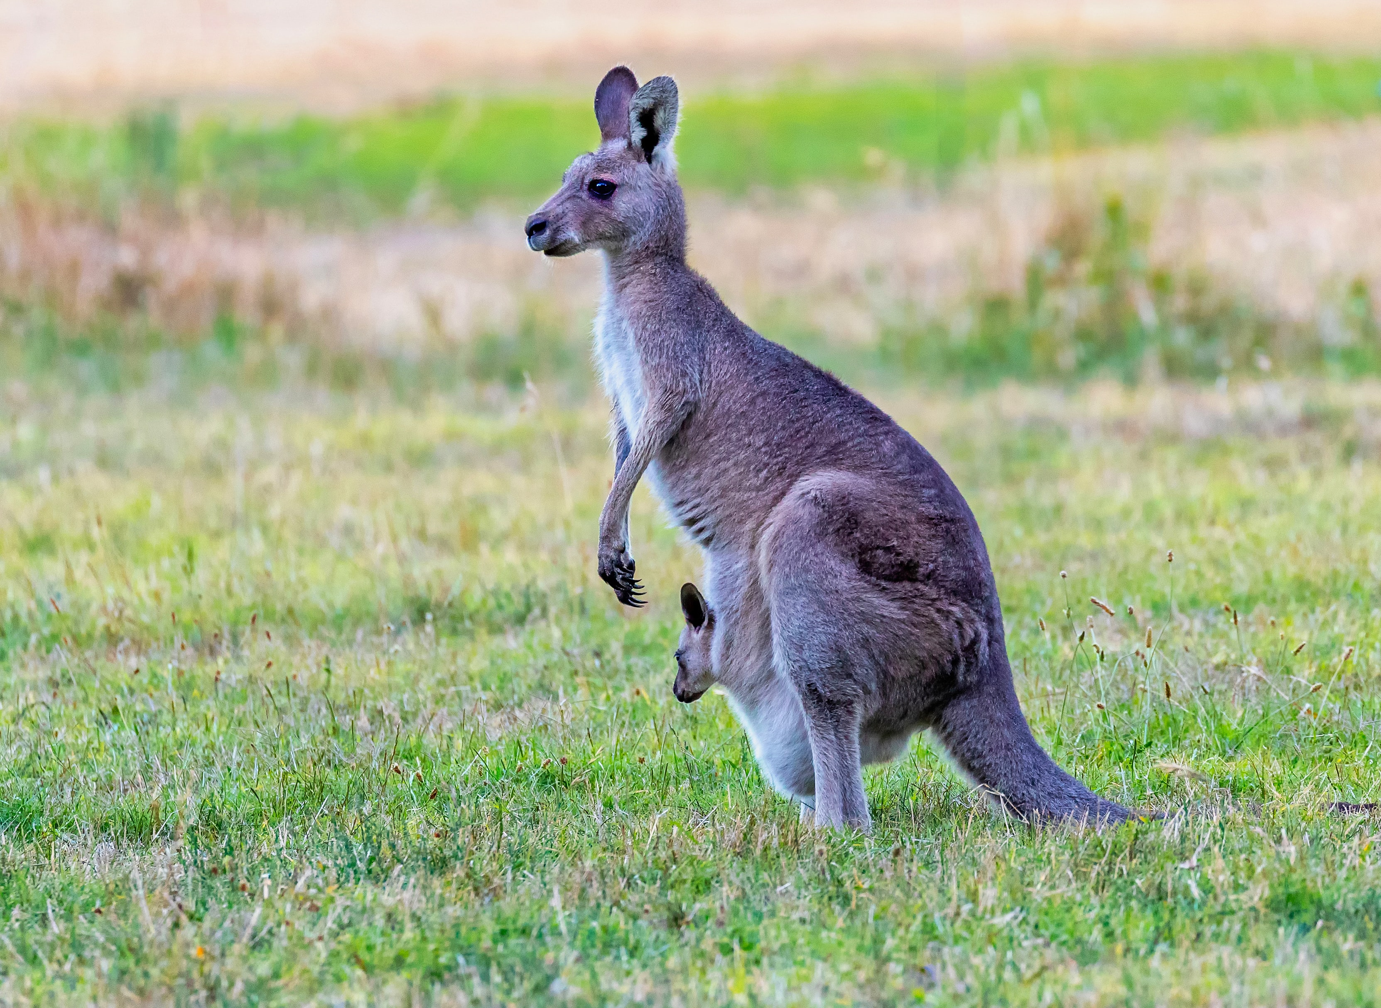

class A **extends** B { … }

should model the real world: It should be the case that an A actually *is a* B.

As an example, a marsupial *is a* mammal, and a kangaroo *is a* marsupial. Therefore, the following declarations make sense:

class Mammal { … }  
 class Marsupial **extends** Mammal { … }  
 class Kangaroo **extends** Marsupial { … }

It would not make sense to have class Cat or class House extend class Marsupial because cats and houses are not marsupials.

The distinctive feature of marsupials is that they have a pouch —or at least the females do. In the picture of a kangaroo above, you can see the mother kangaroo’s joey[1] in her pouch.

This illustrates a general notion that a subclass provides more properties, or more information, in the form of fields or methods. A method could be entirely new or could override a method in the superclass.

Marsupials[2] have a pouch; other mammals don’t. Class Marsupial could have a boolean field joey to indicate, for a female, whether she has an infant in her pouch.

1. A marsupial’s infant is known as a *joey*.
2. *Marsupial* is derived from the word *marsupium*, which is the technical term for the pouch.